
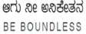

BENGALURU CITY UNIVERSITY

CHOICE BASED CREDIT SYSTEM
(Semester Scheme with Multiple Entry and Exit Options for Under Graduate Course)

Syllabus for Zoology (V & VI Semester)

2023-24

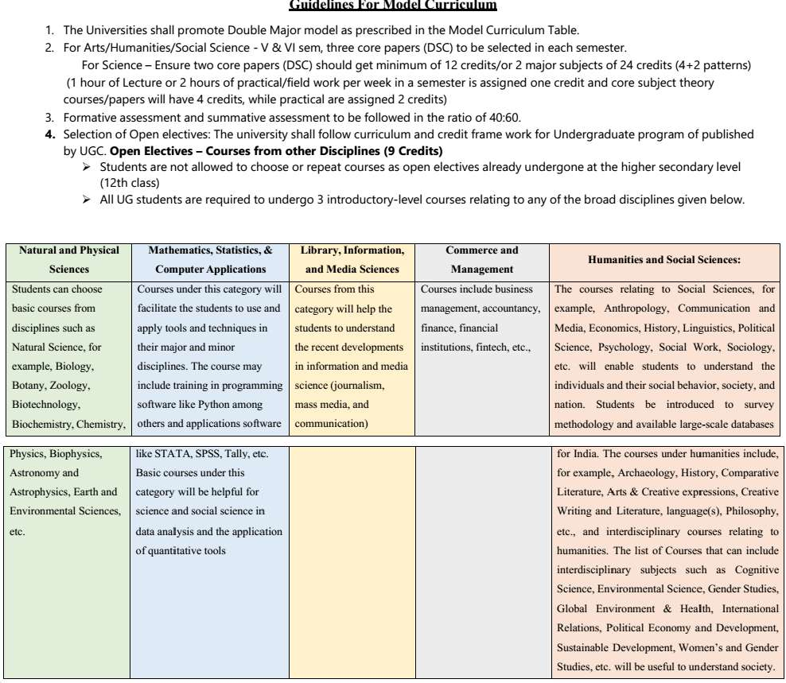

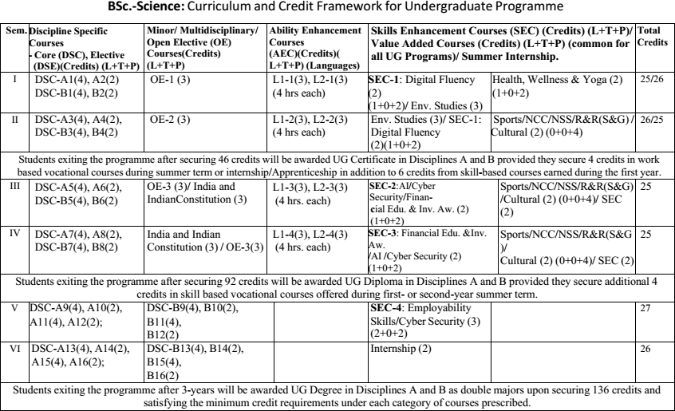
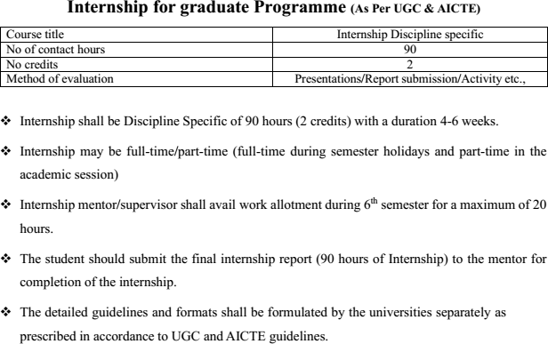

Subject Expert Committee Members -KSHEC

S. No. | Name and Organization | Designation
1 | Prof. K. Vijaykumar, Department of Zoology, Gulbarga University, Kalaburagi. Ph:.9480060508,katepaga63@gmail.com | Chairman
2 | Prof. P.M Basha, Department of Zoology, Bangalore University, Bengaluru Ph:.9448701652, pmbashabub@rediffmail.com | Member
3 | Prof. Vijaykumar B Malashetty, Department of Zoology, VSK University, Ballari. Ph:.9343011567,vijaymalashetty@gmail.com | Member
4 | Prof. S. Basavarajappa, Mysore University, Mysuru. Ph:.9449203241, E-mail: ornithoraj11@gmail.com | Member
5 | Prof. Nagaraj, Department of Zoology, Kuvempu University, Shivamogga. Ph:.9620485338 | Member
6 | Prof. Kareemunnisa Syed, Nrupathunga University, Bengaluru, Ph:.9964300991, kareemunnisa66@gmail.com | Member
7 | Prof. B. Vasanthkumar, Department of Zoology, Sir MVGovt. College,Bhadravathi,Shimoga | Member
8 | Prof. B.K. Meera, Professor, Maharani Cluster University, Bengaluru Ph:.9886409382. | Member
9 | Dr. D. Gangadhara Rao, Professor, Govt. Women’s College, Kolar.  Ph:.9448984956 | Member
10 | Prof. Shankarappa S.Hatti, Govt. College, Dept. of Zoology, SedamRoad,Kalaburagi.9980391964 | Member
11 | Dr. Zeba Parveen Dept. Of Zoology, Bi Bi Raza Women’s Degree  College, Kalaburagi. Ph:.9448092786 | Member
12 | Dr. Asiya Nuzhath F.B, Associate Professor, Dept. Of Zoology, Tumkur University, Tumakuru. Ph:.9844029441 | Member
13 | Ms. Akshatha, Special Officer, KSHEC, Bengaluru. Ph:.9535487108 | Member Convener

Bengaluru City University Subject Committee BOS members for Zoology

SN | Name& Organization | Designation
1 | Dr. P. MAHABOOB BASHA, Prof. of Zoology, Bangalore  University, Bangalore-560056. | Chairman
2 | Dr. HEMALATHA A. Prof. of Zoology, Maharani Cluster University,  Bangalore- 560001. | Member
3 | Dr. SHABANA BEGUM. Prof. of Zoology, Maharani Cluster University  Bangalore- 560001 | Co-opted Member(E)
4 | Dr. LATHA, V. Asso. Prof. of Zoology, Maharani Cluster University,  Bangalore- 560001 | Co-opted Member(E)
5 | Mr. CHANDRAPPA, Associate Prof. of Zoology, GFGC, Yelahanka, Bangalore. 9886884996. | Member
6 | Mrs. DHANALAKSHMI. N, Asst. Prof of Zoology, Vijaya College, RV  Road, Bangalore-560004. | Member
7 | Dr. C.E. TRIVENI, V.V. Puram College of Science, K. R. Road, Bangal | Member
8 | Dr. SHUBHA M, Assistant Professor in zoology, BMS College for  Women, Bengaluru-560004. | Member
9 | Dr. BHUSHANAM. Asso. Prof. of Zoology, Maharani Cluster Universit  Bangalore- 560001 | Co-opted Member(E)
Note:
1. Sl. No 3-4 & 9 were co-opted in the place of Superannuated BOS members.

(P. MAHABOOB BASHA)
Chairman, BOS (UG)Zoology, BCU

VI SEMESTER CURRICULUM

Program Name | B.Sc., |  |  | Semester | VI
Course Title | Evolutionary & Developmental Biology (Theory)
Course Code: | DSCC5 ZOO –T7 |  | No. of Credits |  | 4
Contact hours | 60 Hours |  | Duration of SEA/ Exam |  | 2hours
Formative Assessment Marks |  | 40 | Summative Assessment Marks |  | 60
Course Pre-requisite(s): Objectives
- To understand the biological evolution on the earth
- To understand various forces influencing the evolution
- To understand how the single cell formed at fertilization forms an embryo and then a full adult organism.

Course Outcomes(COs): After the successful completion of the course, the student will be able to:
- Understand that by biological evolution we mean that many of the organisms that inhabit the earth today are different from those that inhabited it in the past.
- Understand that natural selection is one of several processes that can bring about evolution, although it can also promote stability rather than change.
- Understand how the single cell formed at fertilization forms an embryo and then a full adult organism.
- Integrate genetics, molecular biology, biochemistry, cell biology, anatomy and physiology during embryonic development.
- Understand a variety of interacting processes, which generate an organism’s
heterogeneous shapes, size, and structural features.
- Understand how a cell behaves in response to an autonomous determinant or an external signal, and the scientific reasoning exhibited in experimental life science.
Course Articulation Matrix: Mapping of Course Out comes (COs) with Program Out comes (POs)
 | Course Out comes(COs)/(POs) | ZOO C5T | ZOO C5P | ZOO C6T | ZOO C6P | DSCC5 ZOO  –T7 | ZOO C7P | ZOO C8T | ZOO C8P
 | I Core competency |  |  |  |  | X
 | II Critical thinking |  |  |  |  | X
 | III Analytical reasoning |  |  |  |  | X
 | IV Research skills |  |  |  |  | X
 | V Team work |  |  |  |  | X

Contents | 60Hrs
Unit-I | 15
- Theories of Evolution
  - Origin of Life (Contributions of Oparin, Haldane, Stanley Miller’s
experiment).
  - Historical review of evolutionary concept: Lamarckism, Darwinism, Modern synthetic theory
  - Adaptive radiations: Patterns of evolution (Divergence, Convergence, Parallel, Co-evolution)
- Population Genetics
  - Microevolution and Macroevolution: allele frequencies, genotype frequencies, Hardy- Weinberg equilibrium
  - Forces of evolution: Mutation, Natural Selection (Introduction, Types- Stabilising selection, Disruptive selection, Directional selection), Genetic
drift (Introduction, Types- Founder’s effect, Bottle neck effect).
Unit-II | 15
- Direct Evidences of Evolution:
  - Fossils- Types of fossils (Petrifactions, Preservations, Impressions, Moulds and casts), Dating of fossils (Carbon-14 dating method and U-Pb dating method)
  - Phylogeny of horse (Eohippus, Mesohippus, Merichippus, Pliohippus and Equus).
- Species Concept and Extinction:
  - Biological species concept (Advantages and Limitations)
  - Modes of Speciation-Allopatric and Sympatric speciation
(Pre- zygotic and Post Zygotic reproductive isolating mechanisms to be emphasized).
  - Mass extinction (Causes, Names of five major extinctions).
Unit-III | 15
5. Gamete, Fertilization and Early Development:
Gametogenesis (mechanism of Spermatogenesis and oogenesis), Fertilization, Cleavage pattern, Gastrulation and fate map and morphogenesis- General account in the light of evolution to be emphasized.
- Developmental Genes:
  - General concepts of Organogenesis-I (Neurulation process)
  - Introduction to genetic basis of embryonic development and Developmental control genes (Homeobox genes)
Unit-IV | 15
- Early Vertebrate Development:
  - Early development of mammals including Placentation, metamorphosis, regeneration (Limb in frog), environmental regulation in Frog.
- Late Development:
  - Development of eye and kidney
  - Mammalian female reproductive cycles- estrous cycle and menstrual cycle and their regulation
  - Aging: biology of senescence (causes of ageing to be emphasized)

Formative Assessment for Theory
Assessment Occasion /type | Marks
House Examination/ Test | 15
Written Assessment /Presentation/Project/Term Papers/Seminars | 15
Classroom Performance/Participation | 10
Total | 40 Marks
Formative Assessment as per NEP guidelines are compulsory
Topics suggested for Continuous Internal Assessment Presentation/ Seminars
- Incomplete fossil record.
- Planes of cleavage
- Types of cleavage
- Influence of yolk on cleavage
- Historical embryology
- Cleidoic egg and its significance
- Mosaic and regulative eggs
- Theories of ageing
- Blastulation – a general account

Pedagogy: Lectures, Presentations, Videos, Assignments and Weekly Formative Assessment Tests

Practical Paper: Evolutionary & Developmental Biology

Program Name | B.Sc., |  |  | Semester | VI
Course Title | Evolutionary & Developmental Biology(Practical)
Course Code: | DSCC5 ZOO –P7 |  | No. of Credits |  | 2
Contact hours | 60 Hours |  | Duration of SEA/ Exam |  | 3 hours
Formative Assessment Marks |  | 25 | Summative Assessment Marks |  | 25

Course Pre-requisite(s): Course Pre-requisite(s): Objectives
- To understand the biological evolution on the earth
- To understand various forces influencing the evolution
- To understand how the single cell formed at fertilization forms an embryo and then a full adult organism.
Course Articulation Matrix: Mapping of Course Outcomes (COs) with Program Outcomes (POs)
 | Course Out  comes(COs)/(POs) | ZOO C5T | ZOO C5P | ZOO C6T | ZOO C6P | ZOO C7T | DSCC5  ZOO –P7 | ZOO C8T | ZOO C8P
 | I Core competency |  |  |  |  |  | X
 | II Critical thinking |  |  |  |  |  | X
 | III Analytical reasoning |  |  |  |  |  | X
 | IV Research skills |  |  |  |  |  | X
 | V Team work |  |  |  |  |  | X
Course Articulation Matrix relates course out comes of course with the corresponding program out comes whose attainment is attempted in this course. Mark ’X‘ in the inter section cell if a course outcome addresses a particular program outcome.

Formative Assessment for Practical
Assessment Occasion/type | Marks
House Examination/Test | 05
Written Assessment/Presentation/Project/Term Papers/Seminars | 10
Class room Performance / Participation | 10
Total | 25 Marks
Formative Assessment as per NEP guide lines are compulsory

Practical Content 15
1. Study of fossils from models/ pictures. | 2
2. Study of homology and analogy from suitable specimens | 2
3. Study and verification of Hardy-Weinberg Law by chi square analysis.(Any three problems) | 1
4. Types of eggs based on quantity and distribution of yolk: Sea urchin, insect, frog , Chick. | 2
5. Study of adaptive radiations in feet of birds and mouth parts of insects. | 2
6. Study of mammalian placenta- Histological and morphological types | 2
7. Chick Embryology: Egg, Sperm, Primitive streak, 24H, 36H and 48  Hours embryo whole mount. | 2
8. Evolution of man- Ramapithecus, Australopithecus, Neanderthal man  and Cromagnon man | 2

References
1 | Ridley, M (2004) Evolution (3rdedition) Black well Publishing
2 | Hall, B.K. and Hallgrimson, B (2008) Evolution (4thedition) Jones and Barlett Publishers
3 | Barton, N. H., Briggs, D. E. G., Eisen, J. A., Goldstein, D. B. and Patel, N. H. (2007). Evolution. Cold Spring, Harbour Laboratory Press.
4 | Campbell, N. A. and Reece J. B. (2011). Biology. IX Edition, Pearson, Benjamin, Cummings.
5 | Douglas, J. Futuyma (1997). Evolutionary Biology. Sinauer Associates.
6 | Developmental Biology: T. Subramaniam, (Reprint), Narosa Publishing House Pvt. Ltd., New Delhi
7 | Developmental biology: Werner A. Müller, Springer Science &amp; Business Media. (2012).
8 | Human Embryology and Developmental Biology E-Book: Bruce M. Carlson, Elsevier Health Sciences.
9 | Developmental Biology: Michael J. F. Barresi, Scott F. Gilbert, Oxford University Press. (2019).

PAPER: ENVIRONMENTAL BIOLOGY, WILDLIFE MANAGEMENT &CONSERVATION (THEORY)

Program Name |  | B.Sc., |  |  |  | Semester |  |  |  |  | VI
Course Title |  | Environmental Biology, Wildlife Management &Conservations (Theory)
Course Code: |  | DSCC5 ZOO –T8 |  |  |  | No. of Credits |  |  |  |  | 4
Contact hours |  | 60 Hours |  |  |  | Duration of SEA/Exam |  |  |  |  | 2Hours
Formative Assessment Marks |  |  | 40 |  |  | Summative Assessment Marks |  |  |  |  | 60
Course Pre-requisite(s): Objectives
- To understand the interaction between the animals and abiotic factors in the environment
- To use the fundamental principles of wildlife ecology to solve local, regional and national conservation and management issues.
- To gain an appreciation for the modern scope of scientific inquiry in the field of wildlife conservation management.
Course Outcomes (COs): After the successful completion of the course, the student will be able to:
CO1. Develop an understanding of how animals interact with each other and their natural environment.
CO2. Develop the ability to use the fundamental principles of wildlife ecology to solve local, regional and national conservation and management issues.
CO3.Develop the ability to work collaborative team-based projects.
CO4.Gain an appreciation for the modern scope of scientific inquiry in the field of wildlife conservation management.
CO5.Develop an ability to analyze, present and interpret wildlife conservation Management in formation.
 | Course Out comes(COs)/(POs) |  | ZOO C5T | ZOO C5P | ZOO C6T |  | ZOO C6P | ZOO C7T | ZOO C7P | DSCC5 ZOO –  T8 |  | ZOO C8P
 | I Core competency |  |  |  |  |  |  |  |  | X
 | II Critical thinking |  |  |  |  |  |  |  |  | X
 | III Analytical reasoning |  |  |  |  |  |  |  |  | X
 | IV Research skills |  |  |  |  |  |  |  |  | X
 | V Team work |  |  |  |  |  |  |  |  | X
Contents |  |  |  |  |  |  |  |  |  |  |  |  | 60 Hrs
Unit-I |  |  |  |  |  |  |  |  |  |  |  |  | 15
1 Ecology:
- Introduction to ecology, Definition, ecosystem, trophic levels, food chain and food web.
- Aquatic environment (Pond and marine)
- Biomes – definition, Terrestrial (Tundra, alpine, forest, tropical savanna, grassland, desert, wetland)
- Ecological factors (Biotic and Abiotic)

Unit-II | 15
- Pollution:
  - Definition, types (air, soil, water and thermal), ozone layer depletion, bioaccumulation, Biomagnification and bioremediation.
  - Effects of all pollution types on animals and plants
Unit-III | 15
3. Wildlife Conservation: Causes and depletion of wildlife, Ex-situ and in-situ conservation, National parks, Wildlife sanctuaries, biosphere reserve. Project tiger. Project Elephant, Project Lion, breeding in captivity, Zoological gardens, Wildlife
Protection Act 1972.
Unit-IV | 15
4. Wildlife Management: Values of wildlife, inventory and classification of wetlands and their biotic components, general strategies and issues, concept of home range, wildlife corridors and territory, animal census, tracing movement and remote sensing and GIS.

Course Articulation Matrix: Mapping of Course Outcomes (COs) with Program Outcomes (POs1-15)

Pedagogy: Lectures, Presentations, Videos, Assignments and Weekly Formative Assessment Tests

Formative Assessment for Theory
Assessment Occasion/type | Marks
House Examination/Test | 15
Written Assessment/Presentation/Project/Term Papers/Seminars | 15
Classroom Performance/ Participation | 10
Total | 40Marks
Formative Assessment as per NEP guidelines are compulsory
Topics suggested for Continuous Internal Assessment Presentation/ Seminars
- Adaptive features of plants and animals to different environment
- Factors: Weather, Climate, Light, soil, temperature
- Biodiversity- Types, hotspots and methods of preservation

PAPER: ENVIRONMENTAL BIOLOGY, WILDLIFE MANAGEMENT &CONSERVATIONS (PRACTICAL)

Course Title |  | Environmental Biology, Wildlife Management & Conservation  (Practicals) |  |  |  |  |  | Practical Credits |  | 2
Course Code |  | DSCC5 ZOO –P8 |  |  |  |  |  | Contact Hours |  | 4 Hours
Formative Assessment |  | 25Marks |  |  |  |  |  | Summative Assessment |  | 25 Marks
 | Course Out  comes(COs)/(POs) |  | ZOO  C5T | ZOO  C5P | ZOO  C6T | ZOO  C6P | ZOO  C7T | ZOO  C7P | ZOO  C8T |  | ZOO  C8P
 | I Core competency |  |  |  |  |  |  |  |  |  | X
 | II Critical thinking |  |  |  |  |  |  |  |  |  | X
 | III Analytical reasoning |  |  |  |  |  |  |  |  |  | X
 | IV Research skills |  |  |  |  |  |  |  |  |  | X
 | V Team work |  |  |  |  |  |  |  |  |  | X
Practical Content 15
1. Water quality parameters assessment: Collection of water sample, Dissolved Oxygen (O2), Carbon dioxide (CO2), Biological Oxygen  Demand (BOD) Chemical Oxygen Demand (COD), chlorides, Hardness and salinity estimation in water. (Any four) |  |  |  |  |  |  |  |  |  | 5
2. Analysis of physico-chemical parameters of soil: pH, soil moisture, soil  temperature, organic matter in soil. |  |  |  |  |  |  |  |  |  | 3
3. Analysis of air pollution: Air monitoring for particulate matter |  |  |  |  |  |  |  |  |  | 1
4. Visit of pond and lakes: Collection and identification of fauna of selected  ecosystems. Collection, preservation of phytoplanktons, zooplanktons and insect larva.. |  |  |  |  |  |  |  |  |  | 1
5. Demonstration of field equipments used in wildlife census: Compass, Binoculars, Spotting scope, Range Finders, Global Positioning System,  Various types of cameras and lenses. |  |  |  |  |  |  |  |  |  | 2
6. Identification wild animals: Wild animal’s pugmarks, hoof marks scars,  pellet groups, nest, antlers. Demonstration of field techniques for wild fauna. |  |  |  |  |  |  |  |  |  | 1
7. Field visit to nearby National park/ Wildlife sanctuary/ any National laboratory at the end of semester is compulsory and the report of this is to be submitted along with practical record as a part of practical  examination. |  |  |  |  |  |  |  |  |  | 2

Pedagogy: Lectures, Presentations, Videos, Assignments and Weekly Formative Assessment Tests

Formative Assessment for Practical
Assessment Occasion/type | Marks
House Examination/Test | 05
Written Assessment /Presentation/Project/Term Papers/Seminars | 10
Classroom Performance /Participation | 10
Total | 25Marks
Formative Assessment asper NEP guidelines are compulsory

References
1 | Colinvaux, P. A.(1993) Ecology (2ndedition)Wiley, John and Sons, Inc.
2 | Krebs,C. J.(2001)Ecology(6thedition) Benjamin Cummings.
3 | Odum,E.P., (2008) Fundamentals of Ecology. IndianEdition. Brooks/Cole. (3rdEdition) BlackwellSci.
4 | Kendeigh, FC.(1984) Ecology with Special Reference to Animal and Man. Prentice HallInc.
5 | Caughley,G. and Sinclair, A.R.E.(1994)Wildlife Ecology and Management. Blackwell Science.
6 | Woodroffe,R., Thirgood, S. and Rabinowitz,A. (2005) People and Wildlife, Conflict Or Co-existence? Cambridge University.
7 | Bookhout,T.A. (1996) Research and Management Techniques for Wildlife and Habitats (5thedition) The  Wildlife Society,Allen Press.
8 | Sutherland, W.J. (2000)The Conservation Handbook: Research, Management and Policy. Blackwell Sciences
9 | Hunter M.L., Gibbs,J.B. and Sterling,E.J.(2008) Problem solving in Conservation  Biology and Wildlife Management: Exercises for Class, Field, and Laboratory. Blackwell Publishing

Scheme of Practical Examination

VI Semester

Paper VII: DSCC5 ZOO –P7; Evolutionary and Developmental Biology (Practical Based on DSCC5 ZOO –T7)

Duration: 03 Hours Max. Marks 25 M Practical Examination Scheme
- Identify and comment on spotters A and B 3X2 = 06M (Homologous/Analogous organ/Fossil Model) (Any Two)
- Problem on Hardy-Weinberg Law- Chi square analysis (Problems related to evolution) 04 M

- Identify and comment on slide C, D and E 3X4 = 12M (Frog/Chick embryology slides)

- Identify and comment on F 03M
(Any one Human fossil)

Scheme of Valuation
  - Identification -01 M; Comments - 02M for each

  - Problem 04 M

  - Identification 01 M; Comment with diagram 03 M IV.Identification 01M; Comments 02M

***

VI Semester

Paper VIII: DSCC5 ZOO –P8 :Environmental Biology Wildlife Management and Conservation
(Practical Based on DSCC5 ZOO –T8)

Duration: 3 hours Max. Marks: 25

- Estimation of given Water sample for (any one) 12 M (Dissolved O2/CO2/Hardness/Chloride)

- Detect the Physico-chemical parameter of the soil (any one) 04 M (pH, Moisture, Soil temperature, Organic matter)
- Identify and Comment of the spot A & B 3X2 = 06 M (Zooplanktons & Fauna of any ecosystem).

- Identify the spot C 03 M
(Binocular, Compass, Lens, Camera, GPS and Spotting Scope).

Scheme of Valuation

I. Principle and procedure Conducting experiments Result & Comment | -06 M  – 04M  - 02M
II. Physical parameter | - 03M
Comment | - 01M
III. Identification | - 01M
Comment | - 02 M
IV.Identification | - 01M
Comment with Application | - 02M

****

For B.Sc., III Year V and VI semesters

ZOOLOGY AND ANOTHER SUBJECT AS DOUBLE MAJORS IN THIRD YEAR

Sem | Disp. | Paper Code | Title | C | T | P | Ex | IA | E | T
V | DSC | C5 ZOO -T5 | Non-chordates and Economic Zoology | 4 | 4 |  | 2 hr | 40 | 60 | 100
V | DSC | C5 ZOO -P5 | Practical Based on Zoo C5 ZOO -T5 | 2 |  | 4 | 3 hr | 25 | 25 | 50
V | DSC | C5 ZOO -T6 | Chordates and Comparative Anatomy | 4 | 4 |  | 2 hr | 40 | 60 | 100
V | DSC | C5 ZOO -P6 | Practical Based on C5 ZOO -T6 | 2 |  | 4 | 3 hr | 25 | 25 | 50
VI | DSC | C5 ZOO -T7 | Evolutionary & Developmental Biology | 4 | 4 |  | 2 hr | 40 | 60 | 100
VI | DSC | C5 ZOO -P7 | Practical Based on C5 ZOO -T7 | 2 |  | 4 | 3 hr | 25 | 25 | 50
VI | DSC | C5 ZOO -T8 | Environmerntal Biology,Wildlife Management & Conservation | 4 | 4 |  | 2 hr | 40 | 60 | 100
VI | DSC | C5 ZOO -P8 | Practical Based on C5 ZOO -T8 | 2 |  | 4 | 3 hr | 25 | 25 | 50

(C: credits; T: theory; P: Practical; Ex: Exam Duration; IA: Internal Assessment; E: Exam marks; T: Total)

Internship Allotment:
Since Double Majors Programme Being Followed in Third Year, Students Can Opt/choose Eighter Zoology Or Another Subject as Internship topic.

