
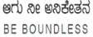

BENGALURU CITY UNIVERSITY

CHOICE BASED CREDIT SYSTEM
(Semester Scheme with Multiple Entry and Exit Options for Under Graduate Course)

Syllabus for Zoology (V & VI Semester)

2023-24

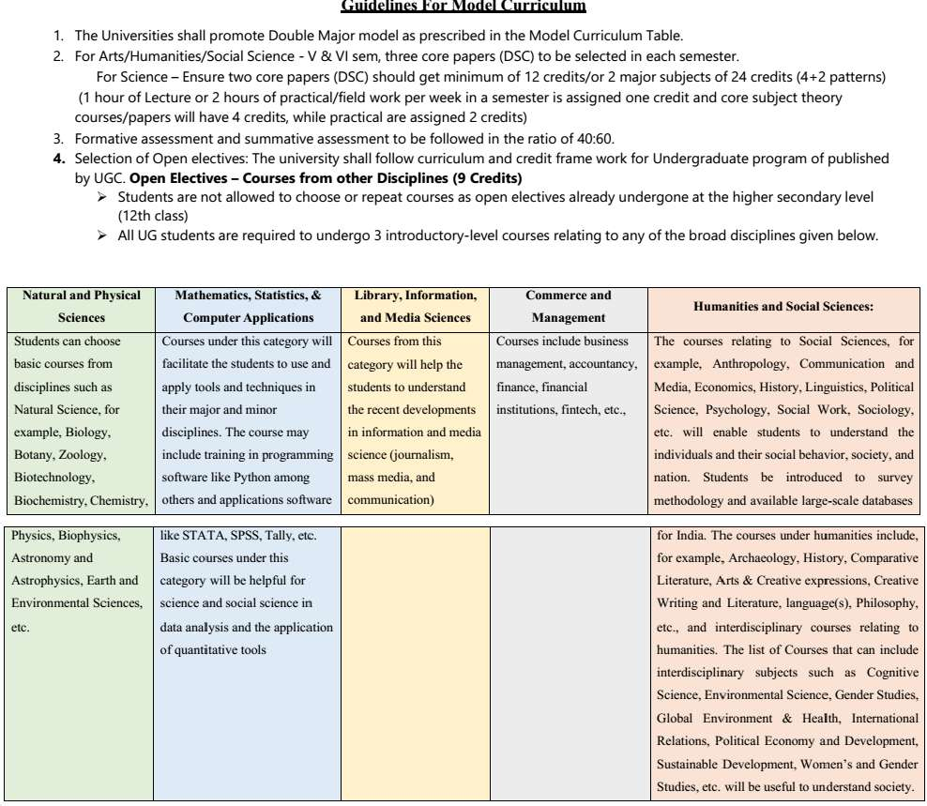

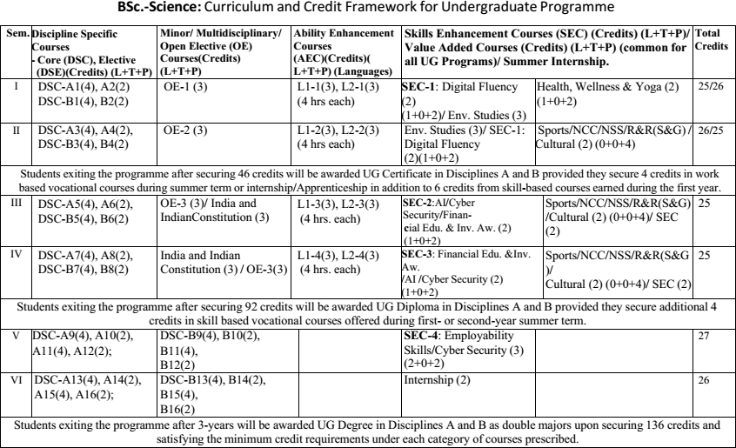
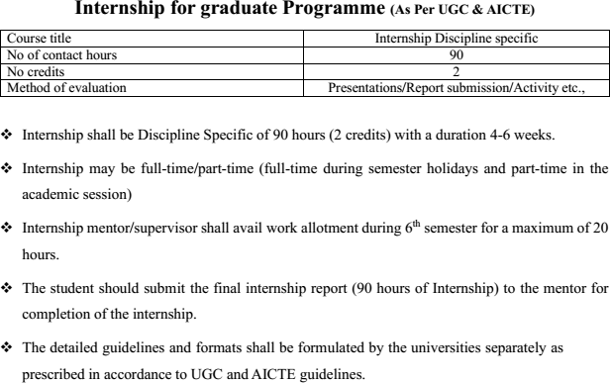

Subject Expert Committee Members -KSHEC

S. No. | Name and Organization | Designation
1 | Prof. K. Vijaykumar, Department of Zoology, Gulbarga University, Kalaburagi. Ph:.9480060508,katepaga63@gmail.com | Chairman
2 | Prof. P.M Basha, Department of Zoology, Bangalore University, Bengaluru Ph:.9448701652, pmbashabub@rediffmail.com | Member
3 | Prof. Vijaykumar B Malashetty, Department of Zoology, VSK University, Ballari. Ph:.9343011567,vijaymalashetty@gmail.com | Member
4 | Prof. S. Basavarajappa, Mysore University, Mysuru. Ph:.9449203241, E-mail: ornithoraj11@gmail.com | Member
5 | Prof. Nagaraj, Department of Zoology, Kuvempu University, Shivamogga. Ph:.9620485338 | Member
6 | Prof. Kareemunnisa Syed, Nrupathunga University, Bengaluru, Ph:.9964300991, kareemunnisa66@gmail.com | Member
7 | Prof. B. Vasanthkumar, Department of Zoology, Sir MVGovt. College,Bhadravathi,Shimoga | Member
8 | Prof. B.K. Meera, Professor, Maharani Cluster University, Bengaluru Ph:.9886409382. | Member
9 | Dr. D. Gangadhara Rao, Professor, Govt. Women’s College, Kolar.  Ph:.9448984956 | Member
10 | Prof. Shankarappa S.Hatti, Govt. College, Dept. of Zoology, SedamRoad,Kalaburagi.9980391964 | Member
11 | Dr. Zeba Parveen Dept. Of Zoology, Bi Bi Raza Women’s Degree  College, Kalaburagi. Ph:.9448092786 | Member
12 | Dr. Asiya Nuzhath F.B, Associate Professor, Dept. Of Zoology, Tumkur University, Tumakuru. Ph:.9844029441 | Member
13 | Ms. Akshatha, Special Officer, KSHEC, Bengaluru. Ph:.9535487108 | Member Convener

Bengaluru City University Subject Committee BOS members for Zoology

SN | Name& Organization | Designation
1 | Dr. P. MAHABOOB BASHA, Prof. of Zoology, Bangalore  University, Bangalore-560056. | Chairman
2 | Dr. HEMALATHA A. Prof. of Zoology, Maharani Cluster University,  Bangalore- 560001. | Member
3 | Dr. SHABANA BEGUM. Prof. of Zoology, Maharani Cluster University  Bangalore- 560001 | Co-opted Member(E)
4 | Dr. LATHA, V. Asso. Prof. of Zoology, Maharani Cluster University,  Bangalore- 560001 | Co-opted Member(E)
5 | Mr. CHANDRAPPA, Associate Prof. of Zoology, GFGC, Yelahanka, Bangalore. 9886884996. | Member
6 | Mrs. DHANALAKSHMI. N, Asst. Prof of Zoology, Vijaya College, RV  Road, Bangalore-560004. | Member
7 | Dr. C.E. TRIVENI, V.V. Puram College of Science, K. R. Road, Bangal | Member
8 | Dr. SHUBHA M, Assistant Professor in zoology, BMS College for  Women, Bengaluru-560004. | Member
9 | Dr. BHUSHANAM. Asso. Prof. of Zoology, Maharani Cluster Universit  Bangalore- 560001 | Co-opted Member(E)
Note:
1. Sl. No 3-4 & 9 were co-opted in the place of Superannuated BOS members.

(P. MAHABOOB BASHA)
Chairman, BOS (UG)Zoology, BCU

V SEMESTER B.Sc., ZOOLOGY THEORY SYLLABUS DISCIPLINE SPECIFIC CORE COURSE (DSCC)

THEORY PAPER: NON-CHORDATES AND ECONOMIC ZOOLOGY

- Course Description

Program Name | B.Sc., |  |  | Semester | V
Course Title | Non-Chordates and Economic Zoology (Theory)
Course Code: | DSCC5 ZOO -T5 |  | No. of Credits |  | 4
Contact hours | 60 Hours |  | Duration of SEA/Exam |  | 2 hours
Formative Assessment Marks |  | 40 | Summative Assessment Marks |  | 60
Course Pre-requisite(s): Objectives:
  - To learn the morphological characters and structure of animals
  - To inculcate the identification abilities in the learners of no- chordate diversity
  - To acquire the knowledge of economic animals
Course Articulation Matrix: Mapping of Course Outcomes (COs) with Program Out comes (POs)

Course Out comes(COs)/(POs) | DSCC5 ZOO -T5 | ZOO C5P | ZOO C6T | ZOO C6P | ZOO C7T | ZOO C7P | ZOO C8T | ZOO C8P
I Core competency | X
II Critical thinking | X
III Analytical reasoning | X
IV Research skills | X
V Team work | X
Course Articulation Matrix relates course outcomes of course with the corresponding program out comes whose attainment is attempted in this course. Mark ‘X’ in the inter section cell if a course outcome addresses a particular program

Course Out comes (COs): After the successful completion of the course, the student will be able to:
CO1. Group animals on the basis of their morphological characteristics/structures. CO2. Demonstrate comprehensive identification abilities of Non-Chordate diversity
CO3.Explain structural and functional diversity of Non-Chordates CO4. Develop the knowledge of economic animals.

Contents | 60 Hrs
Unit-I | 15
Chapter 1: Protozoa to Cnidaria Phylum Protozoa
- Paramecium caudatum- Morphology, Reproduction- Binary fission & Conjugation.
Phylum Porifera
- Sycon- Canal system.
Phylum Coelenterata:
- Obelia- Morphology and Reproduction.
Chapter 2: Ctenophora to Nemathelminthes Ctenophora:
- Salient feature and affinities.
Phylum Platyhelminthes:
- Taenia solium- Morphology and reproduction.
Phylum Nemathelminthes
- Ascaris lumbricoides-Morphology and Reproduction.
Unit-II | 15
- Annelida
  - Hirudinaria granulosa (Leech)-Morphology and Reproduction
- Arthropoda
  - Palaemon (Prawn)- Morphology, Appendages, Nervous System and reproduction
Unit-III | 15
- Mollusca to Hemichordata
Mollusca
  - Pila globosa- Morphology, Shell, Respiration, Nervous System and Reproduction

Echinodermata
    - Pentoceros- Morphology and Water Vascular System

Sub Phylum: Hemichordata
  - Type Study of Balanoglossus–Habit and Habitat, Morphology, Coelom.
  - Tornaria larva.
  - Systematic position of Hemichordata.
Unit-IV | 15
- Economic Zoology Part -I
Life cycle and control of:
  - Gundhi Bug
  - Sugarcane leaf hopper
  - Mosquitoes
- Economic Zoology part II
  - Lac culture and Vermitechnology

Course Articulation Matrix: Mapping of Course Outcomes (COs) with Program Outcomes
Pedagogy: Lectures, Presentations, Videos, Assignments and Weekly Formative Assessment Tests

Formative Assessment for Theory
Assessment Occasion/type | Marks
House Examination/Test | 15
*Written Assessment/Presentation/Project/Term Papers/Seminars | 15
Classroom Performance/Participation | 10
Total | 40 Marks
Topics suggested for Continuous Internal Assessment Presentation/ Seminars

Patterns of Organization (Definition and examples).
  - Levels of organization: Protoplasmic, cellular, tissue, organ and organ system grade.
  - Body symmetry: Bilateral, Radial and Biradial.
  - Germ layers: Diploblastic and Triploblastic.
  - Body coelom: Acoelom, Pseudocoelom and Eucoelom.
    - General characters of all phyla from Protozoa to Hemichordata and classification up to classes with suitable examples.
    - Canal system of sponges

Onychophora- Salient features and affinities
    - Soil protozoa, Spongiculture, Economic importance of corals, Vermi- technology, Importance of Honey bees as pollinators and their by-products, Chank Fisheries and economic importance of Echinodermata.
    - Pisciculture: Procedure, Composite fish farming, Fish processing and preservation
    - Poultry: Indigenous and exotic breeds, Poultry products and by-products
- Dairy: Artificial insemination and MOET, Milk and its by-products, Gobar gas
- Life cycle and control of termites and rodents

PRACTICAL PAPER: NON-CHORDATES AND ECONOMIC ZOOLOGY
Course Out comes(COs)/(POs) | ZOO C5T | DSCC5ZOO  -P5 | ZOO C6T | ZOO C6P | ZOO C7T | ZOO C7P | ZOO C8T | ZOO C8P
I Core competency |  | X
II Critical thinking |  | X
III Analytical reasoning |  | X
IV Research skills |  | X
V Team work |  | X

Course Title | Non-Chordates and Economic Zoology (Practical) | Practical Credits | 2
Course Code | DSCC5 ZOO -P5 | Contact Hours | 4
Formative Assessment | 25 Marks | Summative Assessment | 25 Marks
Course Pre-requisite(s):
- To understand the basics of classification of non-chordates.
- To learn the diversity of habit and habitat of these species.
- To develop the skills to identify different classes and species of animals.
- To know uniqueness of a particular animal and its economic importance
Course Outcomes(COs):

At the end of the course the student should be able to:
- Understand basics of classification of non-chordates.
- Learn the diversity of habit and habitat of these species.
- Develop the skills to identify different classes and species of animals.
- Know uniqueness of a particular animal and its importance

Course Articulation Matrix: Mapping of Course Outcomes (COs) with Program Out comes (POs)

Course Articulation Matrix relates course outcomes of course with the corresponding program outcomes whose attainment is attempted in this course. Mark ‘X’in the intersection cell if a course outcome addresses a particular program outcome.
Practical Content |  |  | 15
- Preparation and observation of protozoan culture.  - Protozoa: Amoeba, Euglena, Noctiluca, Paramecium and Vorticella  (Permanent slides).  - Porifera: Sycon, Euplectella, Hyalonema, Spongilla and Euspongia |  |  | 1

(Specimens). Study of permanent slides of T.S of Sycon, spicules and 1
gemmules.
- Coelenterata: Aurelia and Metridium (Specimens). Slides of Hydra, Obelia-polyp and medusa, and Ephyra larva, T.S. of Metridium passing through mesenteries.
- Stud y of Corals - Astraea, Fungia, Meandrina, Corallium, Gorgonia, Millepora and Pennatula. 1
- Helminthes: Planaria, Fasciola hepatica and Taenia solium, Ascaris- Male and female (Specimens). Slides of T.S. of Planaria, T.S of male and female Ascaris.
- Annelida: Nereis, Sabella, Aphrodite and Leech (Specimens) Slide of 1
T.S. of Earthworm through typhlosole.
- Arthropoda: Palaemon, Astracus, Scorpion, Spider, Limulus, Peripatus, 1
Millipede, Centipede, Praying mantis, Termite Queen, Moth, Butterfly, Dung beetle / Rhinocerous beetle (Any six specimens). Crustacean Larvae-Nauplius, Zoea and Mysis.
- Mollusca: Chiton, Mytilus, Aplysia, Pila, Octopus, Sepia (Specimens) 1
and Glochidium larva (Slide).
- Shell Pattern-Unio, Ostrea, Cypraea, Murex, Nautilus, Patella, Dentalium, Cuttlebone. (Any four)
- Echinodermata: Systematics of Sea-star, Brittlestar, Sea Urchin, Sea 1
cucumber, Sea lily (Specimens). Slides of Bipinnaria larva, Echinopluteus larva and Pedicellaria.
- Balanoglossus and its T. S. through proboscis
- Beneficial Non-chordates: 1
  - Sericulture: Lifecycle of Bombyx mori, Uzifly, Cocoon, Raw silk.
  - Apiculture: Any 2 Species of honeybee and bee wax. 3
  - Pearl Culture: Pearl Oyster and Natural Pearls.
- Virtual Dissection/Cultured specimens: Earthworm – 2
Digestive system, Nervous system, Leech-Digestive System
- Virtual Dissection/Cultured specimens: Prawn-Nervous system. 2
Cockroach-Salivary Apparatus and Digestive system.
Pedagogy: Lectures, Presentations, Videos, Assignments and Weekly Formative Assessment Tests

Formative Assessment for Practical
Assessment Occasion/type | Marks
House Examination/Test | 10
Written Assessment/Presentation/Project/Term  Papers/Seminars | 10
Class room Performance/Participation | 5
Total | 25 Marks

References
1 | Barnes, R.S.K.; Calow,P.; Olive,P.J.W.; Golding,D.W.; Spicer, J.I.(2002) The  Invertebrates: Synthesis, Blackwell Publishing.
2 | Hickman,C.; Roberts,L.S.; Keen,S.L.; Larson, A. and Eisenhour, D. (2018)  Animal Diversity, McGraw-Hill.
3 | Holland, P.(2011) The Animal Kingdom: A Very Short Introduction, Oxford  University Press.
4 | Barrington, E.J.W. (1979) Invertebrate Structure and Functions. II Edition.  E.L.B.S. and Nelson.
5 | Boradale, L.A. and Potts, E.A. (1961) Invertebrates: A Manual for the use of  Students. Asia Publishing Home.
6 | Bushbaum, R. (1964). Animals without Back bones. University of Chicago Press.

THEORY PAPER: CHORDATES AND COMPARATIVE ANATOMY

Program Name |  | B.Sc., |  |  | Semester |  |  |  |  | V
Course Title |  | Chordates and Comparative Anatomy (Theory)
Course Code: |  | DSCC5 ZOO –T6 |  |  | No. of Credits |  |  |  |  | 4
Contact hours |  | 60 Hours |  |  | Duration of SEA/Exam |  |  |  |  | 2 hours
Formative Assessment  Marks |  | 40 |  |  | Summative Assessment  Marks |  |  |  |  | 60
Course Pre-requisite(s): Objectives
- To inculcate identification abilities of chordate diversity
- To explain structural and functional diversity of chordate diversity
- To understand evolutionary relationship amongst chordates
Course Outcomes (COs): After the completion of the course, the student will be able to: CO1. Demonstrate comprehensive identification abilities of chordate diversity
CO2. Explain structural and functional diversity of chordate diversity CO3. Understand evolutionary relationship amongst chordates
CO4. Take up research in biological sciences.
CO5. Realize that very similar physiological mechanisms are used in very diverse organisms. CO6. Get a flavor of research by working on project besides improving their writing skills. It will further enable the students to think and interpret individually.
Course Articulation Matrix: Mapping of Course Outcomes (COs) with Program Outcomes (POs)
 | Course Out comes(COs)/(POs) | ZOO C5T | ZOO C5P | DSCC5ZOO  –T6 |  | ZOO C6P | ZOO C7T | ZOO C7P | ZOO C8T |  |  | ZOO C8P
 | I Core competency |  |  | X
 | II Critical thinking |  |  | X
 | III Analytical reasoning |  |  | X
 | IV Research skills |  |  | X
 | V Team work |  |  | X
Course Articulation Matrix relates course outcomes of course with the corresponding program out comes whose attainment is attempted in this course. Mark ‘X’ in the intersection cell if a course outcome addresses a particular program outcome.
Contents |  |  |  |  |  |  |  |  |  |  | 60Hrs
Unit-I |  |  |  |  |  |  |  |  |  |  | 10 hrs
Chapter 1: Chordata
- General characters of chordates and classification upto classes with suitable examples (Basic features to be emphasized).

Chapter 2: Urochordata
- Type Study of Herdmania- Habit and Habitat, Morphology, Ascidian Tadpole-structure and its retrogressive metamorphosis.

Chapter 3: Cephalochordata
- Type Study of Branchiostoma (Amphioxus)- Habit and Habitat, Morphology, Digestive system, Feeding mechanism, excretory and circulatory systems.

Chapter 4: Agnatha
- General characters of Agnatha and classification up to classes.
- Salient features of Cyclostomata with examples
- Ammocoete larva and its significance.
Unit-II | 16 hrs
Chapter 5: Vertebrates
- General characters and Classification of different classes of vertebrates (Pisces, Amphibia, Reptilia, Aves, Mammalia) upto living orders with examples.
- Differences between Chondrichthyes and Osteichthyes.
- Interesting features and evolutionary significance of Dipnoi.
- Salient features of Placodermi and Ostracodermi with examples.
- Interesting features of Sphenodon,and Archaeopteryx.
- Interesting features of Mammalian orders (Insectivora, Carnivora, Chiroptera, Cetacea, Proboscidia, Ungulata–Perissodactyla and Artiodactyla, and Primates) with examples.
Unit-III | 19 hrs
Chapter 6: General account of Chordates
- Origin of Chordates.
  - Types of caudal fins, scales and swim bladder in fishes.
  - Origin of Amphibia.
  - Neoteny and Paedogenesis.
  - Adaptive radiation in extinct reptiles with suitable examples.
  - Temporal fossae in reptiles.
  - Poison apparatus in snakes.
  - Parental care in Pisces and Amphibians.
  - Flight adaptations in birds.
  - Dentition in mammals. Evolution of molar tooth.
  - Migration in Pisces and Birds.
  - Economic zoology- Poultry
Unit-IV | 15 hrs
Comparative Anatomy of Vertebrates
Chapter 8: Respiratory system
- Comparative account of respiratory system in vertebrates: Pisces (Scolidon), Amphibian (Frog), Reptiles (Lizard), Aves (Pigeon) and Mammals (Man).
Chapter 9: Circulatory System
- Comparative account of heart and aortic arches in vertebrates: Pisces (Scoliodon), Amphibian (Frog), Reptiles (Lizard), Aves (Pigeon) and Mammals (Man).
Chapter 10: Excretory System
  - Succession of kidney in vertebrates (Pronephros, Mesonephros and Meta nephros kidney).
Chapter 11: Nervous system
- Comparative account of brain in vertebrates: Pisces (Scoliodon), Amphibian (Frog), Reptiles (Lizard), Aves (Pigeon) and Mammals (Man).

Course Articulation Matrix: Mapping of Course Outcomes (COs) with Program Outcomes
Pedagogy: Lectures, Presentations, Videos, Assignments and Weekly Formative Assessment Tests

Formative Assessment for Theory
Assessment Occasion/type | Marks
House Examination/Test | 15
*Written Assessment/Presentation/Project/Term Papers/Seminars | 15
Classroom Performance/Participation | 10
Total | 40 Marks
Topics suggested for Continuous Internal Assessment Presentation/ Seminars
- General characters of Urochordata and Cephalochordata.
- Interesting features of crocodile
- Economic zoology- Diary, Pisciculture
- Comparative anatomy of Skeletal system: Axial and appendicular.
- Comparative account of heart in vertebrates
- Comparative account of brain in vertebrates

Practical Paper: Chordates and Comparative Anatomy Zoology

Course Title | Chordates and Comparative Anatomy Zoology (Practical) | Practical Credits | 2
Course Code | DSCC5 ZOO –P6 | Contact Hours | 4
Formative  Assessment | 25 Marks | Summative  Assessment | 25 Marks
Course Pre-requisite(s): Objectives
- To inculcate identification abilities of chordate diversity
- To explain structural and functional diversity of chordate diversity
- To understand evolutionary relationship amongst chordates
Course Outcomes (COs): After the completion of the course, the student will be able to: CO1. Demonstrate comprehensive identification abilities of chordate diversity
CO2. Explain structural and functional diversity of chordate diversity CO3. Understand evolutionary relationship amongst chordates

Practical Content | 15  units
- Protochordata  Ascidia/Herdmania and Amphioxus, T.S. of Amphioxus through pharynx and intestine.  - Cyclostomata  Petromyzon, Ammocoete larva and Myxine.  - Pisces  Cartilaginous Fishes – Narcine, Trygon, Pristis, Myolobaties  Bony Fishes–Zebra fish, Hippocampus, Muraena, Ostracion, Tetradon, Pleuronectus, Diodon, Echeneis. (Any four).  - Ornamental fishes  Siamese, Koi, Oscar, Betta Sp., Neon tetra, Guppies, Goldfish,  Angle fish, Rainbow fish, Mollies  (Locally available any five aquarium fishes).  - Accessory respiratory organs  Saccobranchus, Clarias and Anabas.  - Amphibia  - Rana, Bufo, Ambystoma, Axolotl larva, Necturus and Ichthyophis.  - Reptilia  Turtle, Tortoise, Mabuya, Calotes, Chameleon, Varanus.  snakes–Dryophis, Rat snake, Brahmini, Cobra, Krait, Russell’s viper and Hydrophis (Any 4)  - Aves  Beak and feet modifications in Duck, Crow, Sparrow, Parrot, Kingfisher, Eagle or Hawk. (Any four)  - Mammalia  Mongoose, Squirrel, Pangolin, Hedge Hog, Rat and Loris. (Any four)  - Virtual Dissection/Cultured specimens  Shark/Bony fish: Afferent and efferent branchial systems, glosso-pharyngeal and vagus nerves.  Rat: Dissection (only demonstration) – Circulatory system (arterial and venous), Urogenital system.  - Skeletal System in Frog and man (Comparative Anatomy): Skull, vertebrae, girdles and limb bones (Except hands and feet)  - Integumentary System (Comparative Anatomy) Structure of skin in Fish, Frog, Bird and mammal Integumentary derivatives in mammals. | 1  1  1  1  1  1  1  1  3  2  2

Pedagogy: Lectures, Presentations, Videos, Assignments and Weekly Formative Assessment Tests

Formative Assessment for Practical
Assessment Occasion/type | Marks
House Examination/Test | 10
Written Assessment/Presentation/Project/Term Papers/Seminars | 10
Classroom Performance/Participation | 5
Total | 25 Marks
Formative Assessment as per NEP guidelines are compulsory

References
1 | Colbert et al: Colbert’s Evolution of the Vertebrates:A history of the back boned  animals through time. (5th ed 2002, Wiley–Liss).
2 | Hildebrand: Analysis of vertebrate Structure (4thed 1995, JohnWiley)
3 | Kenneth V. Kardong (20015) vertebrates: Comparative Anatomy, Function,  Evolution McGraw Hill
4 | McFarland et al.,: Vertebrate Life (1979, Macmillan publishing)
5 | Parker and Haswell: Text Book of Zoology, Vol. II(1978,ELBS)
6 | Romerand Parsons: The Vertebrate Body (6thed1986, CBS Publishing Japan)
7 | Young: The Life of vertebrates (3rded 2006,ELBS/Oxford)
8 | Weichert C. K. and William Presch (1970). Elements of Chordate Anatomy, Tata  McGraw Hills
9 | Kardong, K.V. (2006) Vertebrates: Comparative Anatomy, Function, Evolution  (4thedition), McGraw-Hill.

Scheme of Practical Examination
V Semester
PAPER V: DSCC5 ZOO P5: Non- Chordata & Economic Zoology (Practical based on DSCC5 ZOO -T5)
Duration: 03 Hours Max. Marks: 25
- Dissect & display/ Chart
Earthworm/Cockroach: Nervous system/Digestive system (08 M)
- Dissect & display/ Chart
Leech: Digestive system/ Cockroach: Salivary gland apparatus (05M)
- Identify, classify & comment on spots A, B, C and D (3X4 = 12 M) (One from Economic Zoology and one slide is compulsory)

Scheme of Valuation
- – Dissection – 06M; Display – 02 M/ Comments with diagram-8M
- – Mounting – 03M; Comments – 02M/ Comments with diagram-6M
- – Identification & classification – 01M; Diagram & comments – 02M for Each

V Semester
PAPER VI: DSCC5 ZOO P6: Chordata & Comparative Anatomy
(Practical Based on DSCC5 ZOO –T6)
Duration: 3 Hours Max. Marks: 25

Scheme of Examination
  - Flag labeling of the display/ Chart given (ONE) [08M]
    - Shark – Afferent/Efferent/Cranial nerves
    - Rat – Circulatory system/Urinogenital system (Arterial/venous) (Male/Female)
  - Comparative anatomy (ONE) [05M]

    - Skeletal system or Integumentary system for comparison
    - Any TWO derivatives of mammalian integument
  - Identification and comment on spotters A to D [3X4 = 12 M]
    - (Slides & Specimens from Protochordates to Mammalia)
    - One slide is compulsory

Scheme of Valuation
- Identification of the system – 02M; Flag labeling – 06M (Minimum 06 labels)/ Comments with diagram-8M
- Diagram & Comments – 05M
- Identification with classification – 01M; Diagram & Comments – 02 M for each
***

VI SEMESTER CURRICULUM

Program Name | B.Sc., |  |  | Semester | VI
Course Title | Evolutionary & Developmental Biology (Theory)
Course Code: | DSCC5 ZOO –T7 |  | No. of Credits |  | 4
Contact hours | 60 Hours |  | Duration of SEA/ Exam |  | 2hours
Formative Assessment Marks |  | 40 | Summative Assessment Marks |  | 60
Course Pre-requisite(s): Objectives
- To understand the biological evolution on the earth
- To understand various forces influencing the evolution
- To understand how the single cell formed at fertilization forms an embryo and then a full adult organism.

Course Outcomes(COs): After the successful completion of the course, the student will be able to:
- Understand that by biological evolution we mean that many of the organisms that inhabit the earth today are different from those that inhabited it in the past.
- Understand that natural selection is one of several processes that can bring about evolution, although it can also promote stability rather than change.
- Understand how the single cell formed at fertilization forms an embryo and then a full adult organism.
- Integrate genetics, molecular biology, biochemistry, cell biology, anatomy and physiology during embryonic development.
- Understand a variety of interacting processes, which generate an organism’s
heterogeneous shapes, size, and structural features.
- Understand how a cell behaves in response to an autonomous determinant or an external signal, and the scientific reasoning exhibited in experimental life science.
Course Articulation Matrix: Mapping of Course Out comes (COs) with Program Out comes (POs)
 | Course Out comes(COs)/(POs) | ZOO C5T | ZOO C5P | ZOO C6T | ZOO C6P | DSCC5 ZOO  –T7 | ZOO C7P | ZOO C8T | ZOO C8P
 | I Core competency |  |  |  |  | X
 | II Critical thinking |  |  |  |  | X
 | III Analytical reasoning |  |  |  |  | X
 | IV Research skills |  |  |  |  | X
 | V Team work |  |  |  |  | X

Contents | 60Hrs
Unit-I | 15
- Theories of Evolution
  - Origin of Life (Contributions of Oparin, Haldane, Stanley Miller’s
experiment).
  - Historical review of evolutionary concept: Lamarckism, Darwinism, Modern synthetic theory
  - Adaptive radiations: Patterns of evolution (Divergence, Convergence, Parallel, Co-evolution)
- Population Genetics
  - Microevolution and Macroevolution: allele frequencies, genotype frequencies, Hardy- Weinberg equilibrium
  - Forces of evolution: Mutation, Natural Selection (Introduction, Types- Stabilising selection, Disruptive selection, Directional selection), Genetic
drift (Introduction, Types- Founder’s effect, Bottle neck effect).
Unit-II | 15
- Direct Evidences of Evolution:
  - Fossils- Types of fossils (Petrifactions, Preservations, Impressions, Moulds and casts), Dating of fossils (Carbon-14 dating method and U-Pb dating method)
  - Phylogeny of horse (Eohippus, Mesohippus, Merichippus, Pliohippus and Equus).
- Species Concept and Extinction:
  - Biological species concept (Advantages and Limitations)
  - Modes of Speciation-Allopatric and Sympatric speciation
(Pre- zygotic and Post Zygotic reproductive isolating mechanisms to be emphasized).
  - Mass extinction (Causes, Names of five major extinctions).
Unit-III | 15
5. Gamete, Fertilization and Early Development:
Gametogenesis (mechanism of Spermatogenesis and oogenesis), Fertilization, Cleavage pattern, Gastrulation and fate map and morphogenesis- General account in the light of evolution to be emphasized.
- Developmental Genes:
  - General concepts of Organogenesis-I (Neurulation process)
  - Introduction to genetic basis of embryonic development and Developmental control genes (Homeobox genes)
Unit-IV | 15
- Early Vertebrate Development:
  - Early development of mammals including Placentation, metamorphosis, regeneration (Limb in frog), environmental regulation in Frog.
- Late Development:
  - Development of eye and kidney
  - Mammalian female reproductive cycles- estrous cycle and menstrual cycle and their regulation
  - Aging: biology of senescence (causes of ageing to be emphasized)

Formative Assessment for Theory
Assessment Occasion /type | Marks
House Examination/ Test | 15
Written Assessment /Presentation/Project/Term Papers/Seminars | 15
Classroom Performance/Participation | 10
Total | 40 Marks
Formative Assessment as per NEP guidelines are compulsory
Topics suggested for Continuous Internal Assessment Presentation/ Seminars
- Incomplete fossil record.
- Planes of cleavage
- Types of cleavage
- Influence of yolk on cleavage
- Historical embryology
- Cleidoic egg and its significance
- Mosaic and regulative eggs
- Theories of ageing
- Blastulation – a general account

Pedagogy: Lectures, Presentations, Videos, Assignments and Weekly Formative Assessment Tests

Practical Paper: Evolutionary & Developmental Biology

Program Name | B.Sc., |  |  | Semester | VI
Course Title | Evolutionary & Developmental Biology(Practical)
Course Code: | DSCC5 ZOO –P7 |  | No. of Credits |  | 2
Contact hours | 60 Hours |  | Duration of SEA/ Exam |  | 3 hours
Formative Assessment Marks |  | 25 | Summative Assessment Marks |  | 25

Course Pre-requisite(s): Course Pre-requisite(s): Objectives
- To understand the biological evolution on the earth
- To understand various forces influencing the evolution
- To understand how the single cell formed at fertilization forms an embryo and then a full adult organism.
Course Articulation Matrix: Mapping of Course Outcomes (COs) with Program Outcomes (POs)
 | Course Out  comes(COs)/(POs) | ZOO C5T | ZOO C5P | ZOO C6T | ZOO C6P | ZOO C7T | DSCC5  ZOO –P7 | ZOO C8T | ZOO C8P
 | I Core competency |  |  |  |  |  | X
 | II Critical thinking |  |  |  |  |  | X
 | III Analytical reasoning |  |  |  |  |  | X
 | IV Research skills |  |  |  |  |  | X
 | V Team work |  |  |  |  |  | X
Course Articulation Matrix relates course out comes of course with the corresponding program out comes whose attainment is attempted in this course. Mark ’X‘ in the inter section cell if a course outcome addresses a particular program outcome.

Formative Assessment for Practical
Assessment Occasion/type | Marks
House Examination/Test | 05
Written Assessment/Presentation/Project/Term Papers/Seminars | 10
Class room Performance / Participation | 10
Total | 25 Marks
Formative Assessment as per NEP guide lines are compulsory

Practical Content 15
1. Study of fossils from models/ pictures. | 2
2. Study of homology and analogy from suitable specimens | 2
3. Study and verification of Hardy-Weinberg Law by chi square analysis.(Any three problems) | 1
4. Types of eggs based on quantity and distribution of yolk: Sea urchin, insect, frog , Chick. | 2
5. Study of adaptive radiations in feet of birds and mouth parts of insects. | 2
6. Study of mammalian placenta- Histological and morphological types | 2
7. Chick Embryology: Egg, Sperm, Primitive streak, 24H, 36H and 48  Hours embryo whole mount. | 2
8. Evolution of man- Ramapithecus, Australopithecus, Neanderthal man  and Cromagnon man | 2

References
1 | Ridley, M (2004) Evolution (3rdedition) Black well Publishing
2 | Hall, B.K. and Hallgrimson, B (2008) Evolution (4thedition) Jones and Barlett Publishers
3 | Barton, N. H., Briggs, D. E. G., Eisen, J. A., Goldstein, D. B. and Patel, N. H. (2007). Evolution. Cold Spring, Harbour Laboratory Press.
4 | Campbell, N. A. and Reece J. B. (2011). Biology. IX Edition, Pearson, Benjamin, Cummings.
5 | Douglas, J. Futuyma (1997). Evolutionary Biology. Sinauer Associates.
6 | Developmental Biology: T. Subramaniam, (Reprint), Narosa Publishing House Pvt. Ltd., New Delhi
7 | Developmental biology: Werner A. Müller, Springer Science &amp; Business Media. (2012).
8 | Human Embryology and Developmental Biology E-Book: Bruce M. Carlson, Elsevier Health Sciences.
9 | Developmental Biology: Michael J. F. Barresi, Scott F. Gilbert, Oxford University Press. (2019).

PAPER: ENVIRONMENTAL BIOLOGY, WILDLIFE MANAGEMENT &CONSERVATION (THEORY)

Program Name |  | B.Sc., |  |  |  | Semester |  |  |  |  | VI
Course Title |  | Environmental Biology, Wildlife Management &Conservations (Theory)
Course Code: |  | DSCC5 ZOO –T8 |  |  |  | No. of Credits |  |  |  |  | 4
Contact hours |  | 60 Hours |  |  |  | Duration of SEA/Exam |  |  |  |  | 2Hours
Formative Assessment Marks |  |  | 40 |  |  | Summative Assessment Marks |  |  |  |  | 60
Course Pre-requisite(s): Objectives
- To understand the interaction between the animals and abiotic factors in the environment
- To use the fundamental principles of wildlife ecology to solve local, regional and national conservation and management issues.
- To gain an appreciation for the modern scope of scientific inquiry in the field of wildlife conservation management.
Course Outcomes (COs): After the successful completion of the course, the student will be able to:
CO1. Develop an understanding of how animals interact with each other and their natural environment.
CO2. Develop the ability to use the fundamental principles of wildlife ecology to solve local, regional and national conservation and management issues.
CO3.Develop the ability to work collaborative team-based projects.
CO4.Gain an appreciation for the modern scope of scientific inquiry in the field of wildlife conservation management.
CO5.Develop an ability to analyze, present and interpret wildlife conservation Management in formation.
 | Course Out comes(COs)/(POs) |  | ZOO C5T | ZOO C5P | ZOO C6T |  | ZOO C6P | ZOO C7T | ZOO C7P | DSCC5 ZOO –  T8 |  | ZOO C8P
 | I Core competency |  |  |  |  |  |  |  |  | X
 | II Critical thinking |  |  |  |  |  |  |  |  | X
 | III Analytical reasoning |  |  |  |  |  |  |  |  | X
 | IV Research skills |  |  |  |  |  |  |  |  | X
 | V Team work |  |  |  |  |  |  |  |  | X
Contents |  |  |  |  |  |  |  |  |  |  |  |  | 60 Hrs
Unit-I |  |  |  |  |  |  |  |  |  |  |  |  | 15
1 Ecology:
- Introduction to ecology, Definition, ecosystem, trophic levels, food chain and food web.
- Aquatic environment (Pond and marine)
- Biomes – definition, Terrestrial (Tundra, alpine, forest, tropical savanna, grassland, desert, wetland)
- Ecological factors (Biotic and Abiotic)

Unit-II | 15
- Pollution:
  - Definition, types (air, soil, water and thermal), ozone layer depletion, bioaccumulation, Biomagnification and bioremediation.
  - Effects of all pollution types on animals and plants
Unit-III | 15
3. Wildlife Conservation: Causes and depletion of wildlife, Ex-situ and in-situ conservation, National parks, Wildlife sanctuaries, biosphere reserve. Project tiger. Project Elephant, Project Lion, breeding in captivity, Zoological gardens, Wildlife
Protection Act 1972.
Unit-IV | 15
4. Wildlife Management: Values of wildlife, inventory and classification of wetlands and their biotic components, general strategies and issues, concept of home range, wildlife corridors and territory, animal census, tracing movement and remote sensing and GIS.

Course Articulation Matrix: Mapping of Course Outcomes (COs) with Program Outcomes (POs1-15)

Pedagogy: Lectures, Presentations, Videos, Assignments and Weekly Formative Assessment Tests

Formative Assessment for Theory
Assessment Occasion/type | Marks
House Examination/Test | 15
Written Assessment/Presentation/Project/Term Papers/Seminars | 15
Classroom Performance/ Participation | 10
Total | 40Marks
Formative Assessment as per NEP guidelines are compulsory
Topics suggested for Continuous Internal Assessment Presentation/ Seminars
- Adaptive features of plants and animals to different environment
- Factors: Weather, Climate, Light, soil, temperature
- Biodiversity- Types, hotspots and methods of preservation

PAPER: ENVIRONMENTAL BIOLOGY, WILDLIFE MANAGEMENT &CONSERVATIONS (PRACTICAL)

Course Title |  | Environmental Biology, Wildlife Management & Conservation  (Practicals) |  |  |  |  |  | Practical Credits |  | 2
Course Code |  | DSCC5 ZOO –P8 |  |  |  |  |  | Contact Hours |  | 4 Hours
Formative Assessment |  | 25Marks |  |  |  |  |  | Summative Assessment |  | 25 Marks
 | Course Out  comes(COs)/(POs) |  | ZOO  C5T | ZOO  C5P | ZOO  C6T | ZOO  C6P | ZOO  C7T | ZOO  C7P | ZOO  C8T |  | ZOO  C8P
 | I Core competency |  |  |  |  |  |  |  |  |  | X
 | II Critical thinking |  |  |  |  |  |  |  |  |  | X
 | III Analytical reasoning |  |  |  |  |  |  |  |  |  | X
 | IV Research skills |  |  |  |  |  |  |  |  |  | X
 | V Team work |  |  |  |  |  |  |  |  |  | X
Practical Content 15
1. Water quality parameters assessment: Collection of water sample, Dissolved Oxygen (O2), Carbon dioxide (CO2), Biological Oxygen  Demand (BOD) Chemical Oxygen Demand (COD), chlorides, Hardness and salinity estimation in water. (Any four) |  |  |  |  |  |  |  |  |  | 5
2. Analysis of physico-chemical parameters of soil: pH, soil moisture, soil  temperature, organic matter in soil. |  |  |  |  |  |  |  |  |  | 3
3. Analysis of air pollution: Air monitoring for particulate matter |  |  |  |  |  |  |  |  |  | 1
4. Visit of pond and lakes: Collection and identification of fauna of selected  ecosystems. Collection, preservation of phytoplanktons, zooplanktons and insect larva.. |  |  |  |  |  |  |  |  |  | 1
5. Demonstration of field equipments used in wildlife census: Compass, Binoculars, Spotting scope, Range Finders, Global Positioning System,  Various types of cameras and lenses. |  |  |  |  |  |  |  |  |  | 2
6. Identification wild animals: Wild animal’s pugmarks, hoof marks scars,  pellet groups, nest, antlers. Demonstration of field techniques for wild fauna. |  |  |  |  |  |  |  |  |  | 1
7. Field visit to nearby National park/ Wildlife sanctuary/ any National laboratory at the end of semester is compulsory and the report of this is to be submitted along with practical record as a part of practical  examination. |  |  |  |  |  |  |  |  |  | 2

Pedagogy: Lectures, Presentations, Videos, Assignments and Weekly Formative Assessment Tests

Formative Assessment for Practical
Assessment Occasion/type | Marks
House Examination/Test | 05
Written Assessment /Presentation/Project/Term Papers/Seminars | 10
Classroom Performance /Participation | 10
Total | 25Marks
Formative Assessment asper NEP guidelines are compulsory

References
1 | Colinvaux, P. A.(1993) Ecology (2ndedition)Wiley, John and Sons, Inc.
2 | Krebs,C. J.(2001)Ecology(6thedition) Benjamin Cummings.
3 | Odum,E.P., (2008) Fundamentals of Ecology. IndianEdition. Brooks/Cole. (3rdEdition) BlackwellSci.
4 | Kendeigh, FC.(1984) Ecology with Special Reference to Animal and Man. Prentice HallInc.
5 | Caughley,G. and Sinclair, A.R.E.(1994)Wildlife Ecology and Management. Blackwell Science.
6 | Woodroffe,R., Thirgood, S. and Rabinowitz,A. (2005) People and Wildlife, Conflict Or Co-existence? Cambridge University.
7 | Bookhout,T.A. (1996) Research and Management Techniques for Wildlife and Habitats (5thedition) The  Wildlife Society,Allen Press.
8 | Sutherland, W.J. (2000)The Conservation Handbook: Research, Management and Policy. Blackwell Sciences
9 | Hunter M.L., Gibbs,J.B. and Sterling,E.J.(2008) Problem solving in Conservation  Biology and Wildlife Management: Exercises for Class, Field, and Laboratory. Blackwell Publishing

Scheme of Practical Examination

VI Semester

Paper VII: DSCC5 ZOO –P7; Evolutionary and Developmental Biology (Practical Based on DSCC5 ZOO –T7)

Duration: 03 Hours Max. Marks 25 M Practical Examination Scheme
- Identify and comment on spotters A and B 3X2 = 06M (Homologous/Analogous organ/Fossil Model) (Any Two)
- Problem on Hardy-Weinberg Law- Chi square analysis (Problems related to evolution) 04 M

- Identify and comment on slide C, D and E 3X4 = 12M (Frog/Chick embryology slides)

- Identify and comment on F 03M
(Any one Human fossil)

Scheme of Valuation
  - Identification -01 M; Comments - 02M for each

  - Problem 04 M

  - Identification 01 M; Comment with diagram 03 M IV.Identification 01M; Comments 02M

***

VI Semester

Paper VIII: DSCC5 ZOO –P8 :Environmental Biology Wildlife Management and Conservation
(Practical Based on DSCC5 ZOO –T8)

Duration: 3 hours Max. Marks: 25

- Estimation of given Water sample for (any one) 12 M (Dissolved O2/CO2/Hardness/Chloride)

- Detect the Physico-chemical parameter of the soil (any one) 04 M (pH, Moisture, Soil temperature, Organic matter)
- Identify and Comment of the spot A & B 3X2 = 06 M (Zooplanktons & Fauna of any ecosystem).

- Identify the spot C 03 M
(Binocular, Compass, Lens, Camera, GPS and Spotting Scope).

Scheme of Valuation

I. Principle and procedure Conducting experiments Result & Comment | -06 M  – 04M  - 02M
II. Physical parameter | - 03M
Comment | - 01M
III. Identification | - 01M
Comment | - 02 M
IV.Identification | - 01M
Comment with Application | - 02M

****

For B.Sc., III Year V and VI semesters

ZOOLOGY AND ANOTHER SUBJECT AS DOUBLE MAJORS IN THIRD YEAR

Sem | Disp. | Paper Code | Title | C | T | P | Ex | IA | E | T
V | DSC | C5 ZOO -T5 | Non-chordates and Economic Zoology | 4 | 4 |  | 2 hr | 40 | 60 | 100
V | DSC | C5 ZOO -P5 | Practical Based on Zoo C5 ZOO -T5 | 2 |  | 4 | 3 hr | 25 | 25 | 50
V | DSC | C5 ZOO -T6 | Chordates and Comparative Anatomy | 4 | 4 |  | 2 hr | 40 | 60 | 100
V | DSC | C5 ZOO -P6 | Practical Based on C5 ZOO -T6 | 2 |  | 4 | 3 hr | 25 | 25 | 50
VI | DSC | C5 ZOO -T7 | Evolutionary & Developmental Biology | 4 | 4 |  | 2 hr | 40 | 60 | 100
VI | DSC | C5 ZOO -P7 | Practical Based on C5 ZOO -T7 | 2 |  | 4 | 3 hr | 25 | 25 | 50
VI | DSC | C5 ZOO -T8 | Environmerntal Biology,Wildlife Management & Conservation | 4 | 4 |  | 2 hr | 40 | 60 | 100
VI | DSC | C5 ZOO -P8 | Practical Based on C5 ZOO -T8 | 2 |  | 4 | 3 hr | 25 | 25 | 50

(C: credits; T: theory; P: Practical; Ex: Exam Duration; IA: Internal Assessment; E: Exam marks; T: Total)

Internship Allotment:
Since Double Majors Programme Being Followed in Third Year, Students Can Opt/choose Eighter Zoology Or Another Subject as Internship topic.

