REPORT ON “A TALK ON IPR BASICS FOR INNOVATORS &ENTREPRENEURS”
Organized by:
Institution’s Innovation Council (IIC) & Internal Quality Assurance Cell(IQAC)
Vijaya College, R.V.Road , Basavanagudi, Bengaluru–560004
Affiliated to Bengaluru City University| Accredited by NAAC with B++Grade

Institution’s Innovation Counci l (IIC)
The Institution’s Innovation Council (IIC) is an initiative of the Ministry of Education’s Innovation Cell (MIC), Government of India. It was established to create a strong culture of innovation and entrepreneurship in educational institutions.

Event Details
Topic: “A Talk on IPR Basics for Innovators &Entrepreneurs”
Date: 21st November 2025
Time:10.30AM
Mode: Offline
Speaker: Aaryan DJ Advocate High Court Karnataka

Objective of the Session
The purpose of this session was to provide foundational knowledge and emphasize the importance of protecting their creative ideas and innovations to foster business growth and secure a competitive advantage. To empower emerging fashion innovators to develop an IPR focused mindset so they can commercialize their creations ethically, build sustainable brands and compete confidently in the global market. To create awareness about importance of IPR in protecting original fashion ideas, designs, brand names, textiles and innovations from imitation and misuse among students of BBA and BCA.

Event Proceedings
Welcome Address & Guest Introduction: The session began with a warm welcome by Prof. Vidya Saraswathi K, Convenor, IIC(2025–26).
and introduction of the guest speaker by Prof. Afreen Mohammadi

Guest Talk: Mr.Aaryan DJ delivered an inspiring lecture on IPR Basics for Innovators & Entrepreneurs”. He Stated that IP refers to creations of the mind, inventions, literacy and artistic works and symbols, names, images and designs used in science, technology and commerce. He introduced the participants to the subject of IPR through some real world examples. Then he started explaining the various types of Intellectual property like Patents, Copy Rights, Designs, Geographical Indications, Trademarks, Plant Varieties and Trade Secrets. His talk emphasized the legal framework for IP protection, application processes, and enforcement mechanisms. Participants gained insights into identifying potential IP assets in their innovations, developing effective protection strategies, and exploring opportunities for IP commercialization.
Vote of Thanks: The event concluded with a heartfelt vote of thanks delivered by Prof. Vidya Saraswathi K, Convenor, IIC (2025–26), appreciating the guest speaker, faculty, and all participants.

Participation
Total Participants: 150+ Departments: BBA and BCA Mode: Offline
Students and faculty members actively participated and interacted with the speaker.
Outcomes of the Session:
- The overall outcome of the session was that the participating students benefited and understood the importance of IPR and patenting process and how their ideas can be transformed into products and in turn valuable to society.

Attachments
- Event Brochure

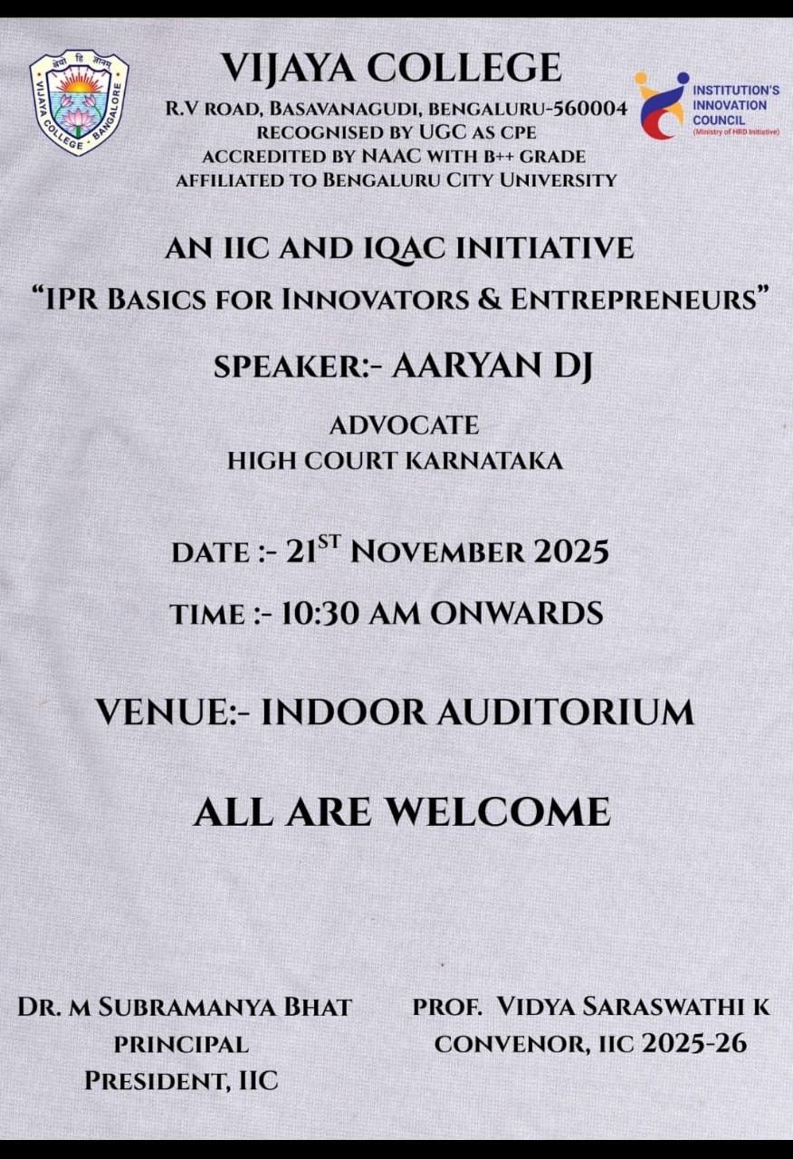

- Session Screenshot.

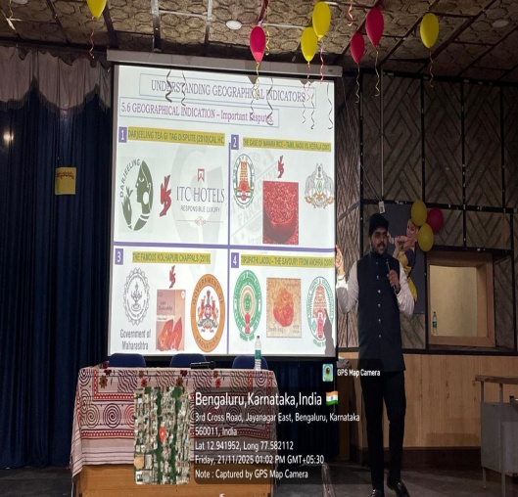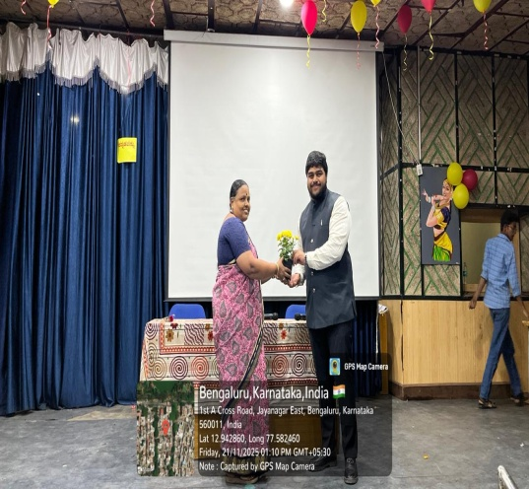

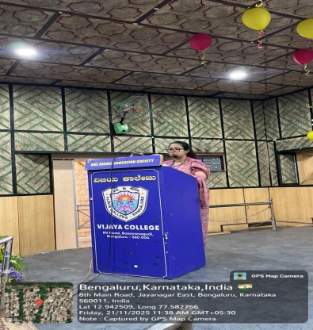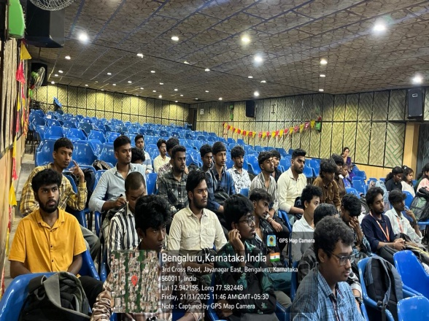
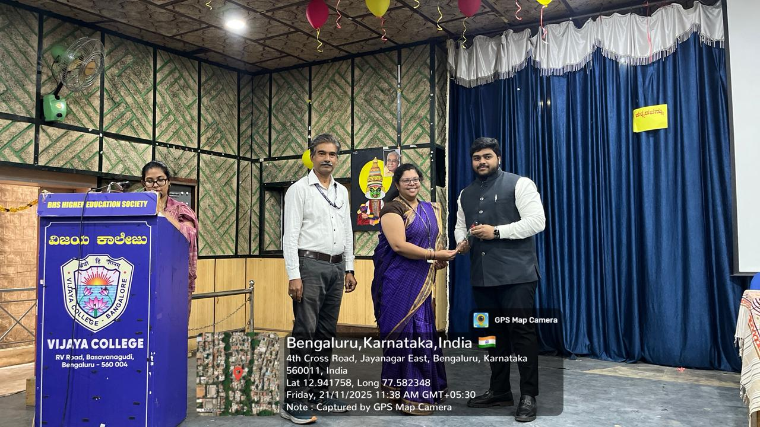

Attendance Screenshots.
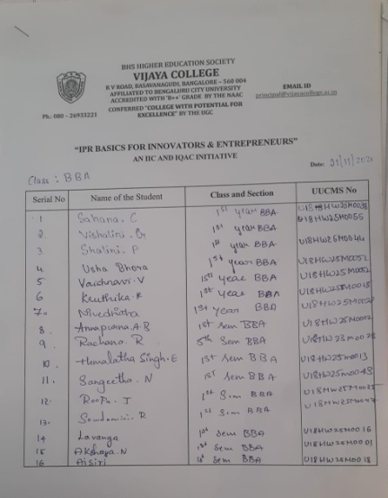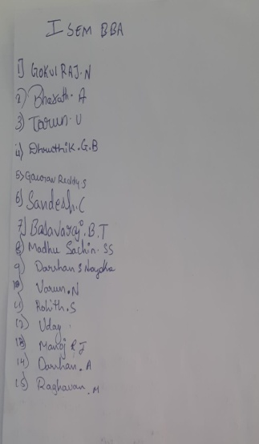
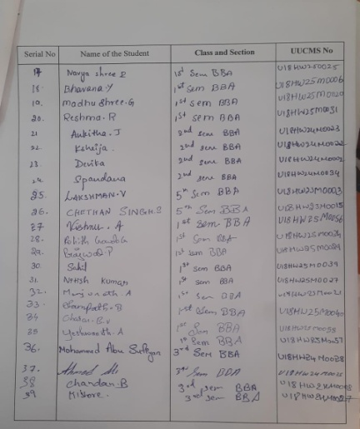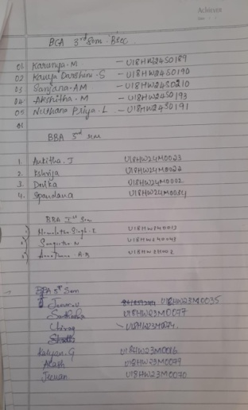

Conclusion
The event concluded with expressing gratitude to Mr. Aaryan DJ for his enlightening talk. IIC initiative “A Talk on IPR Basics for Innovators & Entrepreneurs” was a successful and enriching session that inspired students and provided valuable knowledge and actionable insights on IPR to explore the world of startups and innovation. The interactive talk by Aaryan Dj motivated participants to become visionary leaders and contribute to society through entrepreneurship.
Prepared by:
Institution’s Innovation Council(IIC)
VijayaCollege,Bengaluru–560004

